Master Research Project
Verifying data integrity
Group - 6
Instructor: M.S., & Prof. Srikanth Mudigonda, Ph.D.,
Prof. Ravindranath Arunasalam
Group Members: Sydulu Vemula
Lokesh Mannem
Rupesh Bura
Vydhurya Maheshwaram
Sai Pavan Cheekuri

Data Validation and Integrity Checks
Dataset: https://www.kaggle.com/datasets/uciml/breast-cancer-wisconsin-data/data
1. Introduction
Integrity and validation of data are essential to ensure that the datasets are proper, credible and ready for analysis. The size of dataset under consideration is 33 columns and 569 records. This report is aimed towards the validation of the data and detecting any discrepancies that would doubt the integrity of the data. It includes checking referential integrity, the field level integrity, as well as distributional validity to guarantee data quality.
2. Understanding the Dataset
The dataset has multiple medical diagnostic features, such as id, diagnosis, radius mean, texture mean, perimeter mean, etc. The dataset is supposed to be correct structure and for each row represents a unique medical case, and it needs to have no inconsistencies or missing values in it.
3. Referential Integrity Check
A way to ensure referential integrity is that the primary keys do not repeat and relationships between datasets are correctly maintained. the primary key in this dataset will be the id column. There can be a violation of referential integrity if:
- Duplicate id values exist.
- id values are missing or incorrectly formatted.
Analysis revealed that there are no duplicate id value found, therefore, the primary key is kept intact. This is to ensure that each record is unique and can therefore not be redundant in subsequent analysis to reduce the chance of misclassification.
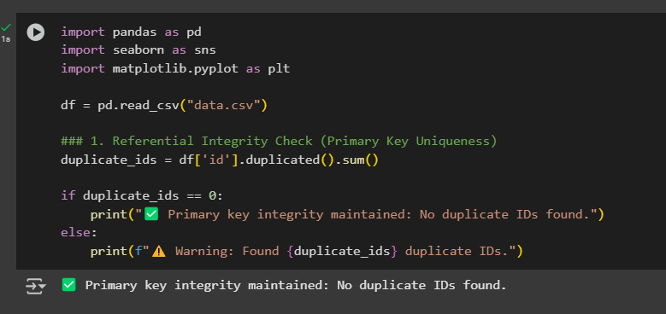
4. Field-Level Integrity Checks
For field level integrity, it means that each attribute stored in the attribute contains valid data within a given rang. Several aspects were examined:
4.1 Missing Values
Actually, any place where there is an issue of missing values can bias a result as well and can lead you to a incorrect conclusion. A missing values analysis was performed on a column by column basis and it was determined that Unnamed: 32 was an empty column containing only null values. It was removed from this column to improve data quality. None of the rest of the dataset had missing values.
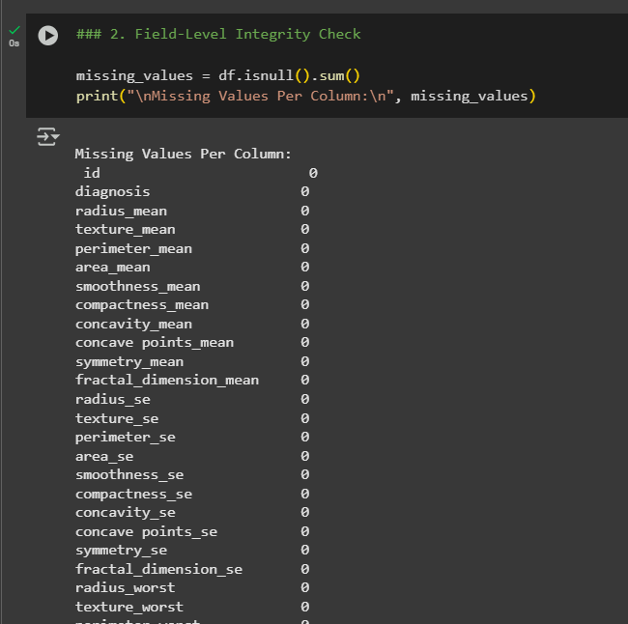
4.2 Data Type Consistency
Each column’s data type was analyzed to confirm consistency:
- id was correctly stored as an integer.
- diagnosis was stored as an object (string), as expected.
- All numerical columns were correctly stored as floating-point numbers.
Ensuring that data types are correct is crucial for preventing errors in computational analysis.
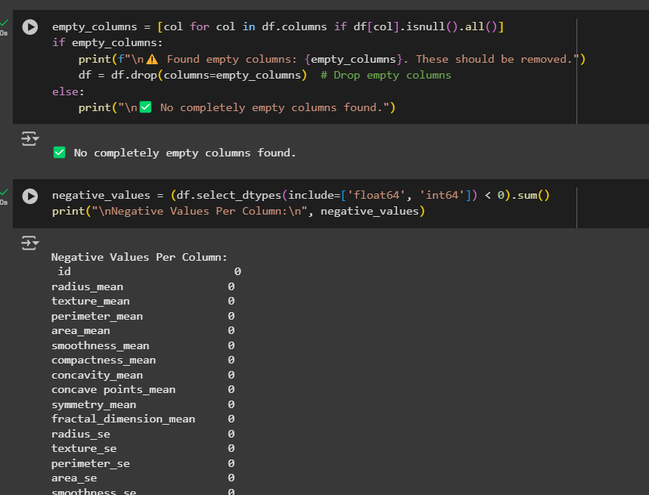
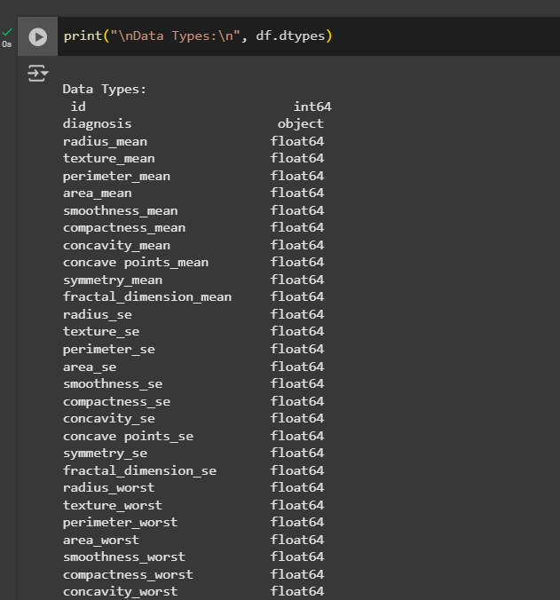
4.3 Negative Values in Numerical Fields
Medical parameters such as radius_mean and area_mean were checked on whether they are negative values in a numerical columns since they should always be non negative though. All the numerical attributes in the dataset have no negative values, that means the dataset doesn’t have any negative values as wrongly stored.
5. Distributional Validity Check
Distributional validity checks are to ensure that the data follows the expectation. Detecting extreme outlier, skewness or incorrect data entry is important.
5.1 Histograms for Feature Distributions
Histograms were made of the key numerical features of the dataset. Most of the variables showed normal or slightly skewed distributions expecting medical datasets. Nevertheless, there were features that indicated heavy tailed distributions, including concavity_mean and concave points_mean, which may indicate potential outliers.
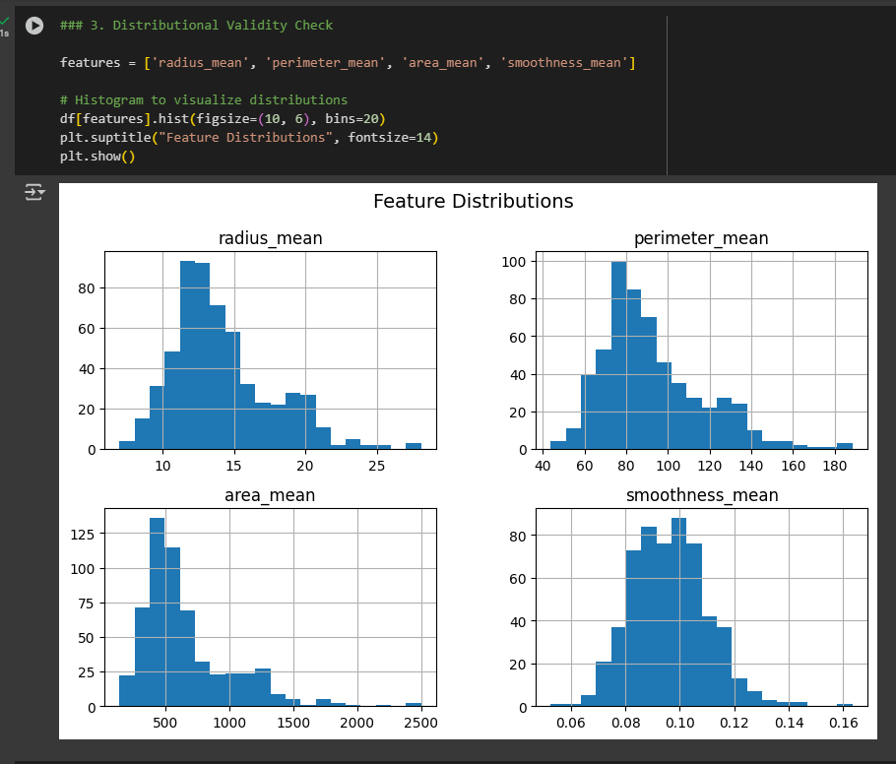

5.2 Boxplot Analysis for Outliers
The extreme values in the numerical features were identified using boxplots. There were several such features like area mean and perimeter mean which were significant outliers. These points, being outliers, are important to medical diagnosis and should not be automatically removed but carefully analyzed. Extreme values present therefore might reveal patients in the dataset who have extreme large or small measurements that are important for clinical research.
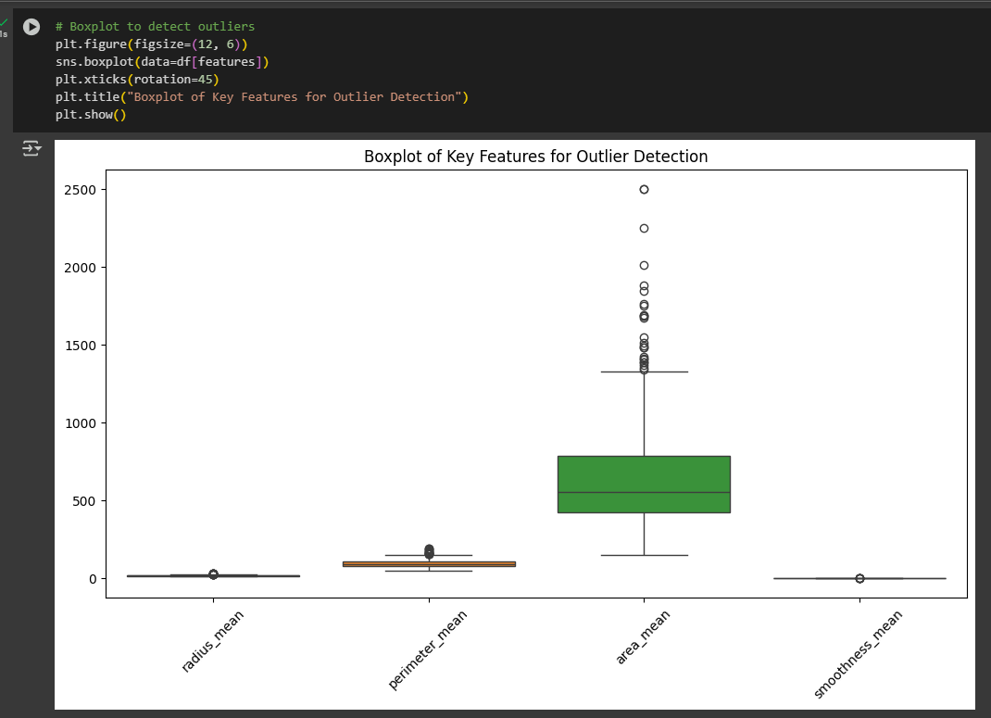
5.3 Interquartile Range (IQR) for Outlier Detection
The Interquartile Range (IQR) method was applied to detect and quantify outliers. The IQR is calculated as: where:
- Q1 is the first quartile (25th percentile)
- Q3 is the third quartile (75th percentile)
Any values lying below or above were considered outliers. Outliers were found in multiple columns, but given the nature of the dataset, these values likely represent genuine patient variations rather than data entry errors.
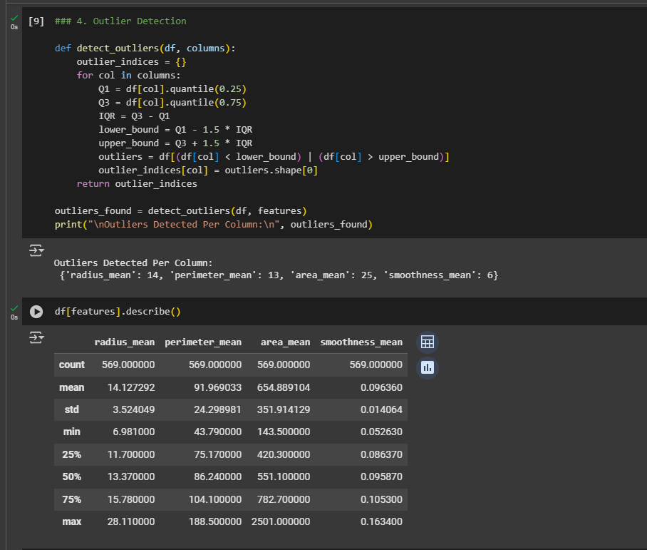
6. Summary of Data Validation Checks
Based on the analysis, the following conclusions can be drawn:
- Primary Key Integrity: No duplicate id value is found, this is to make it as unique as we can.
- Missing Values: One completely empty column (Unnamed: 32) was removed as the missing values. There were no other missing values.
- Negative Values: there were no negative values found, which demonstrates that the data has been entered correctly.
- Data Type Consistency: All columns had appropriate data types.
- Outliers: Multiple features had significant outliers, but these might have been true outliers instead of errors.
7. Conclusion and Recommendations
The dataset generally maintains high data integrity, but minor refinements can enhance its quality further. The key recommendations include:
- Removing the Empty Column: The column Unnamed: 32 should be removed (dropped) in order to clean the dataset.
- Handling Outliers Carefully: As outliers may contain unused and important information for medical analysis, they should not be removed blindly. Instead, these values should instead be further domain specifically validated to ensure they are meaningful.
- Ensuring Future Data Consistency: Validity checks should be performed when an entry is added to prevent missing or incorrect entries.

